**D33/38037/2016**

**MUSYIMI KENNEDY NZYUKO**

**DIS306: DATABASE SYSYEMS**

**ASSIGNMENT**

**TOPIC: DATA MODELLING**

**ENTITY RELATIONSHIP DIAGRAM FOR QUICKFOODS RESTAURANT ORDERING SYSTEM**

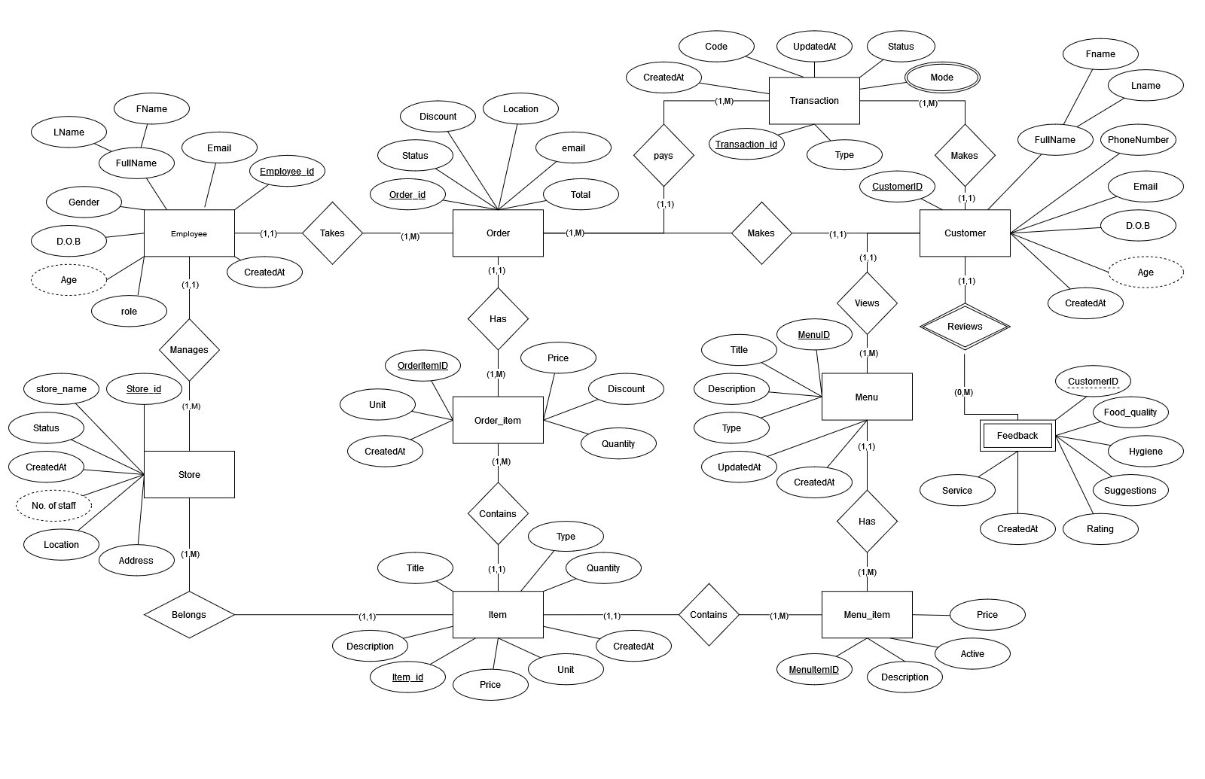

**A) DESIGN VIEW OF QUICKFOODS RESTAURANT ORDERING SYSTEMS TABLES WITH PRIMARY KEYS**

**Overview of the tables**

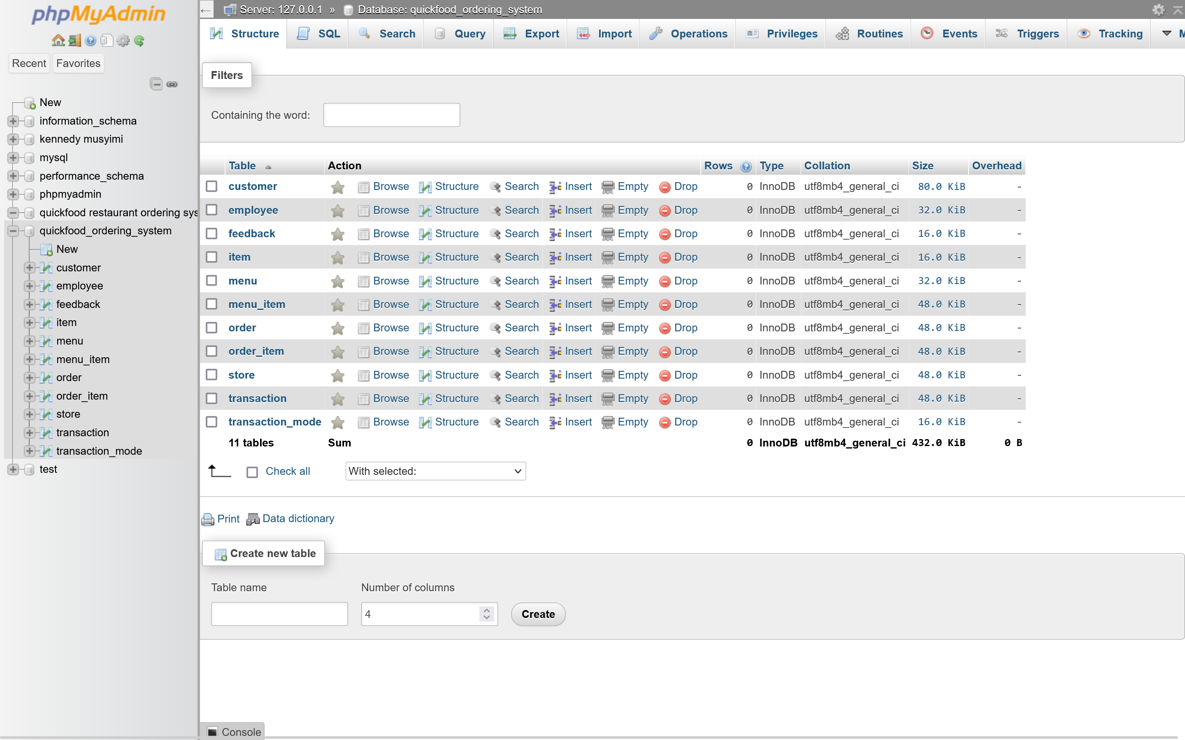

**1) Customer’s table design**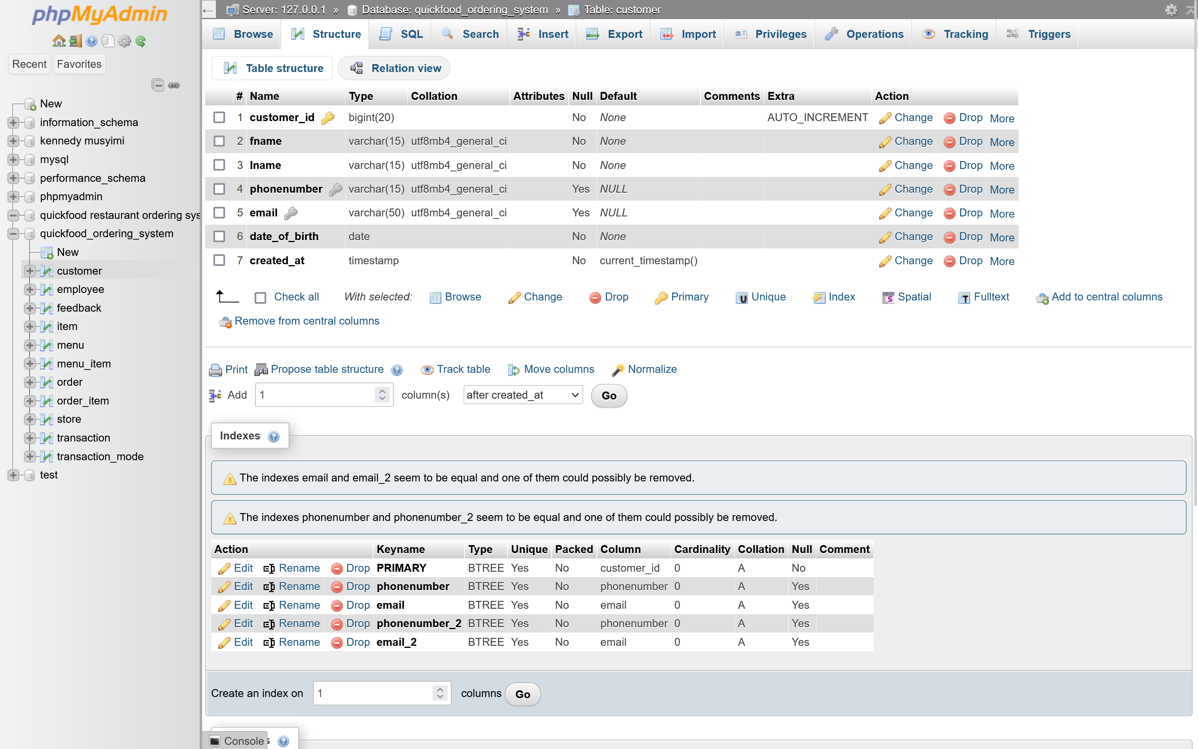

**2) Employee’s table design**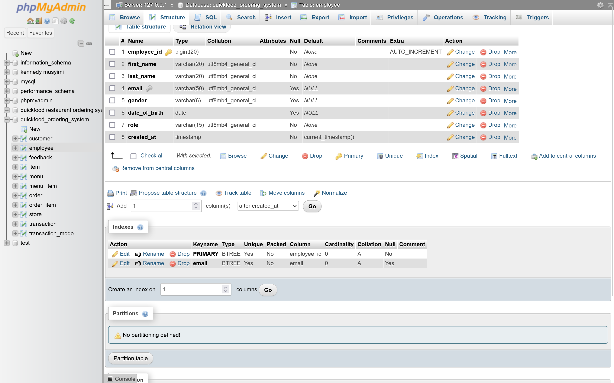

**3) Feedback’s table design**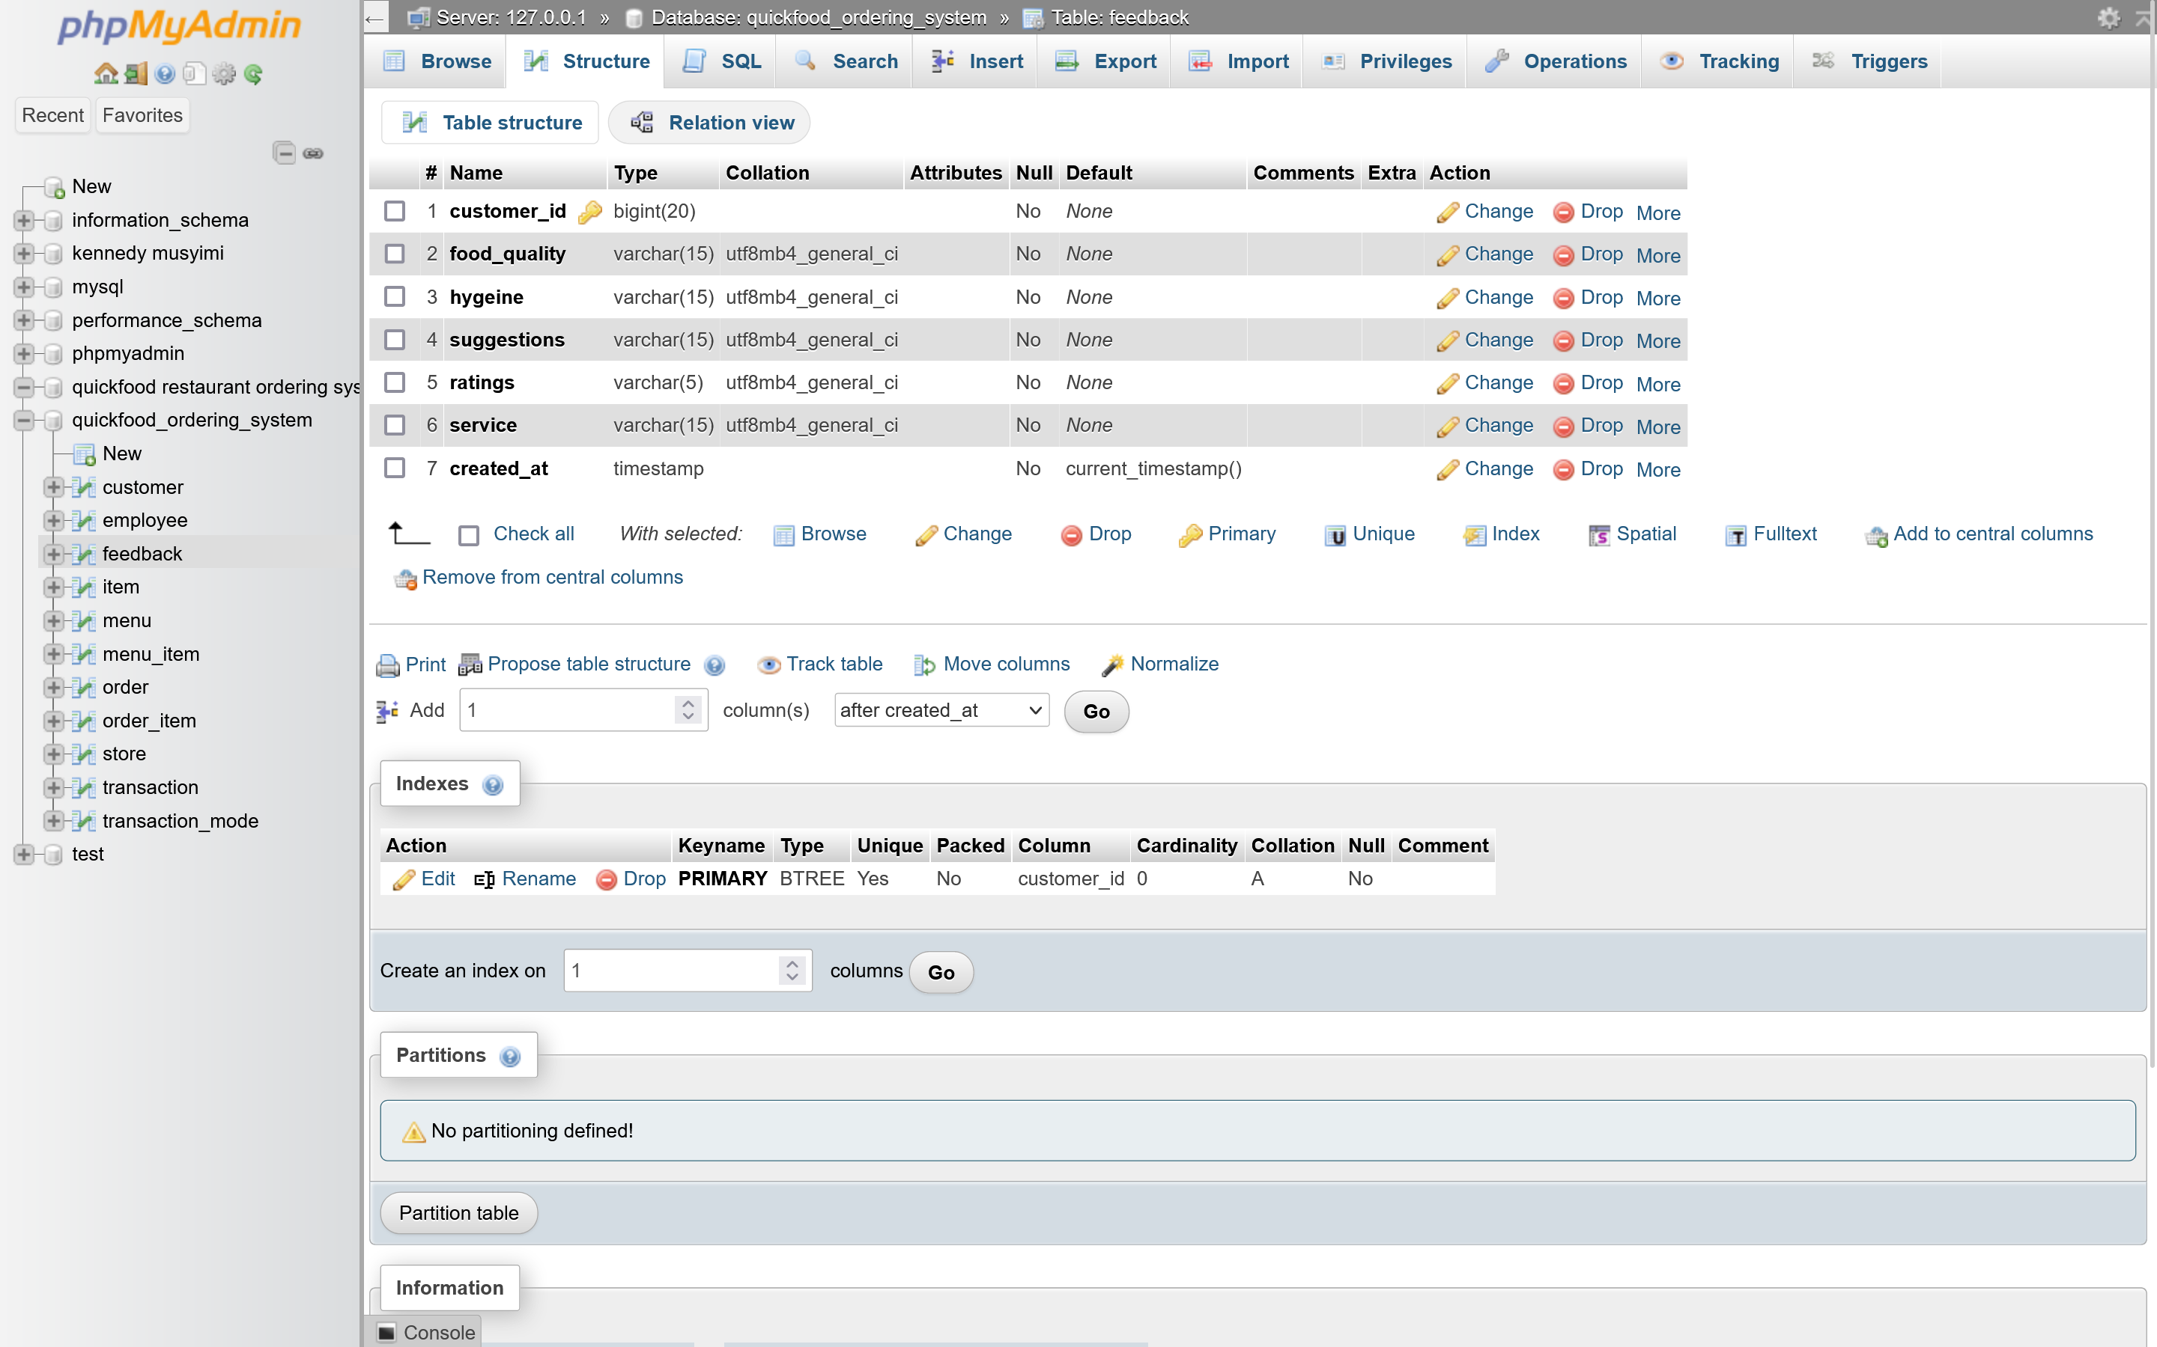

**4) Item’s table design**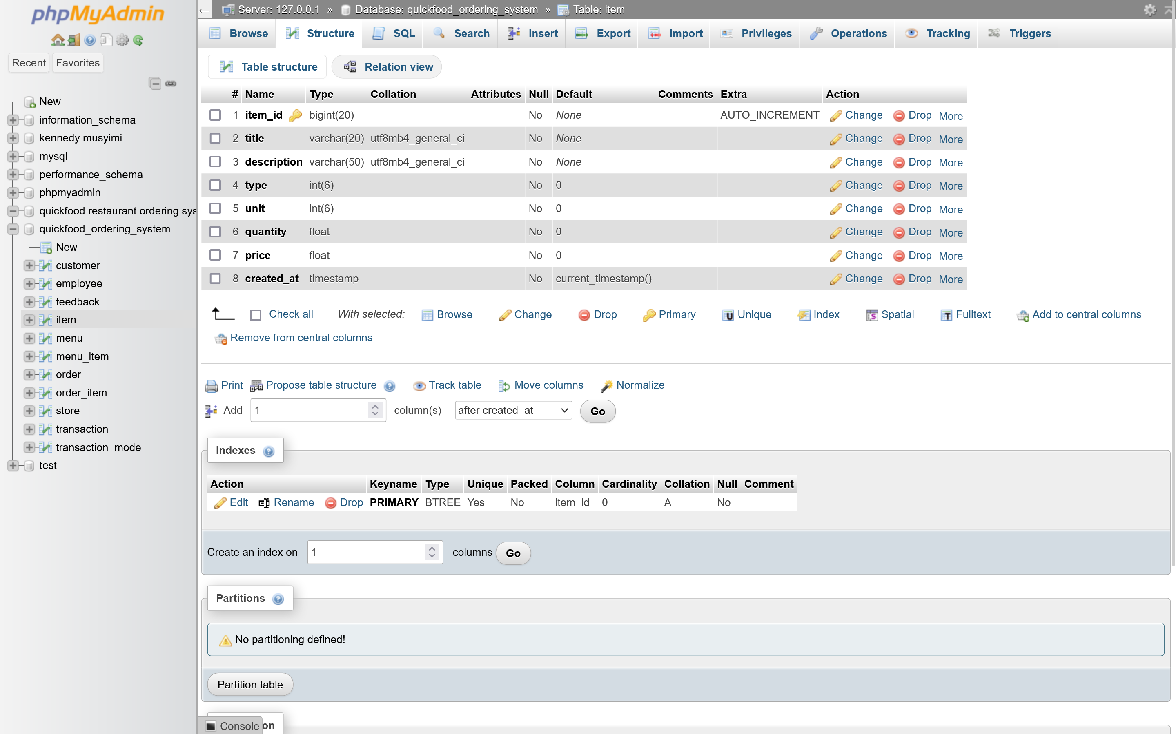

**5) Menu’s table design**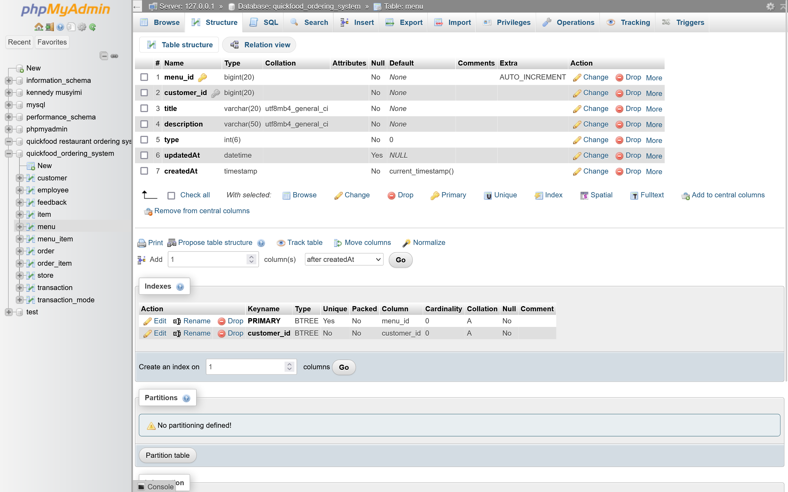

**6) Menu item’s table design**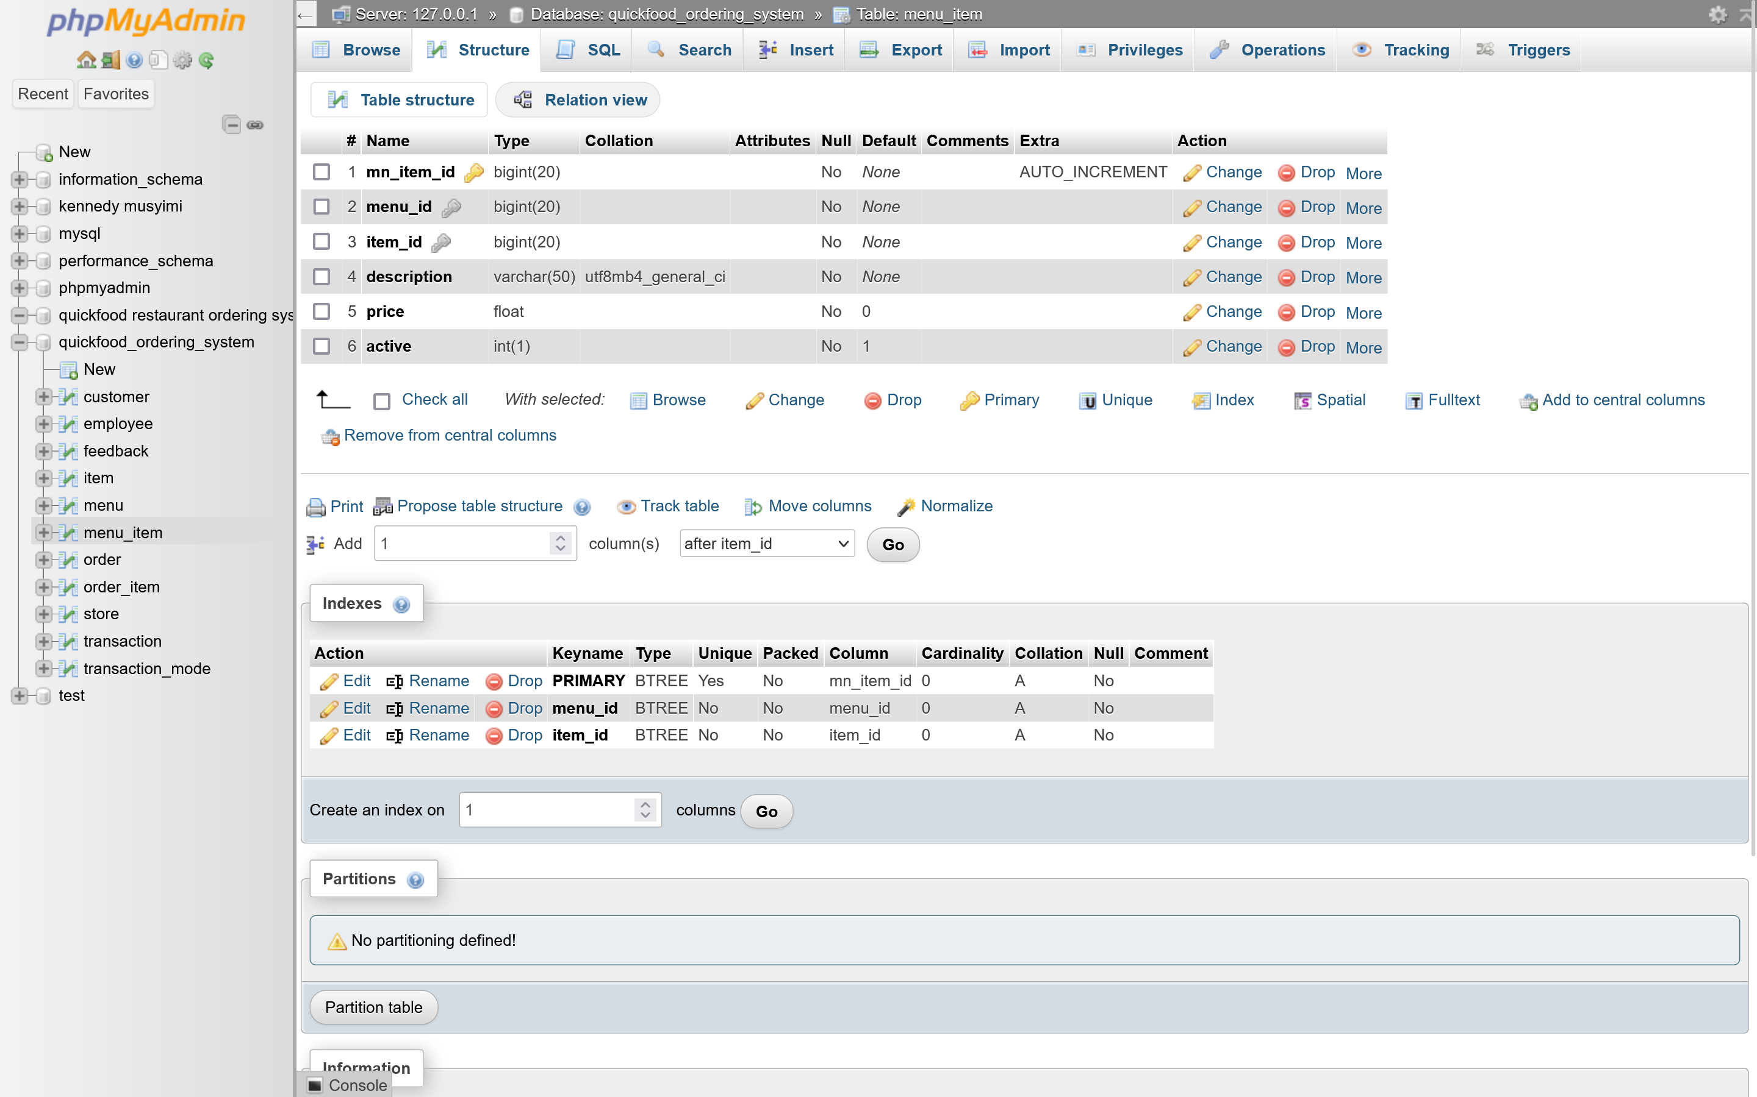

**7) Order’s table design**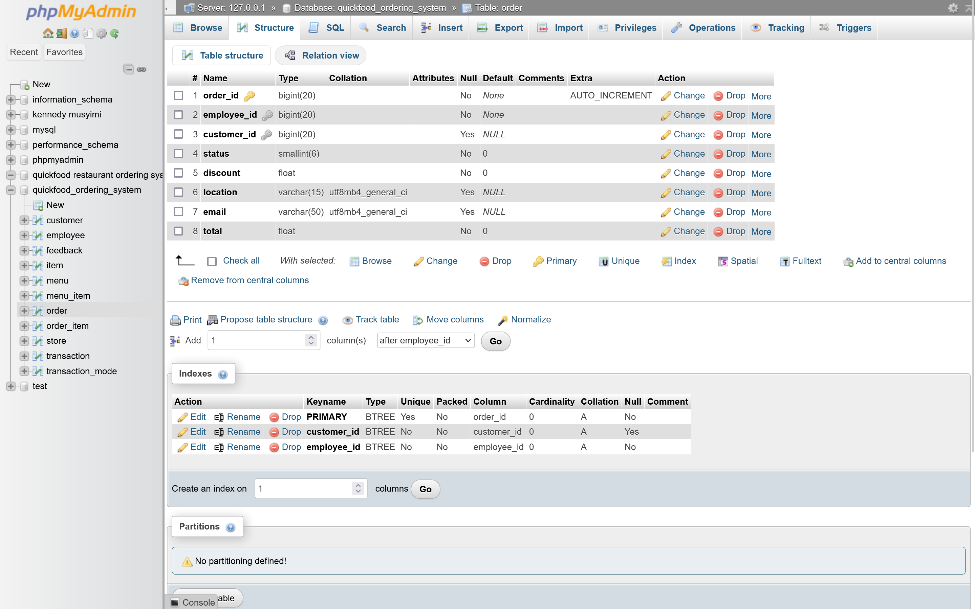

**8) Order item’s table design**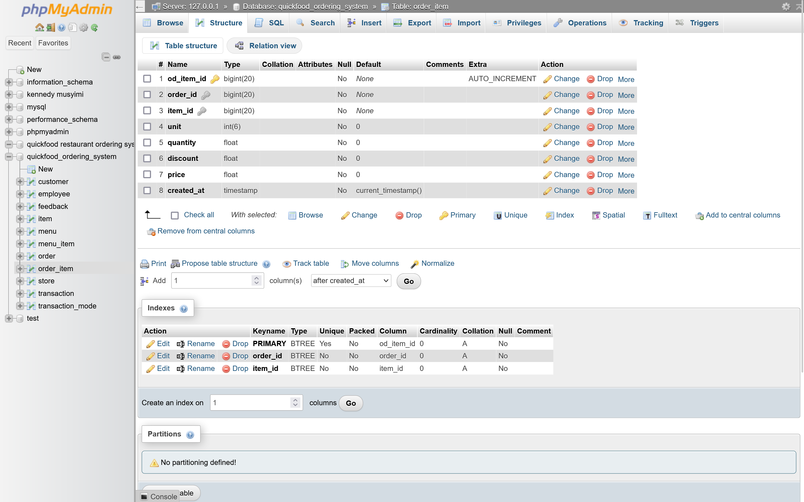

**9) Store’s table design**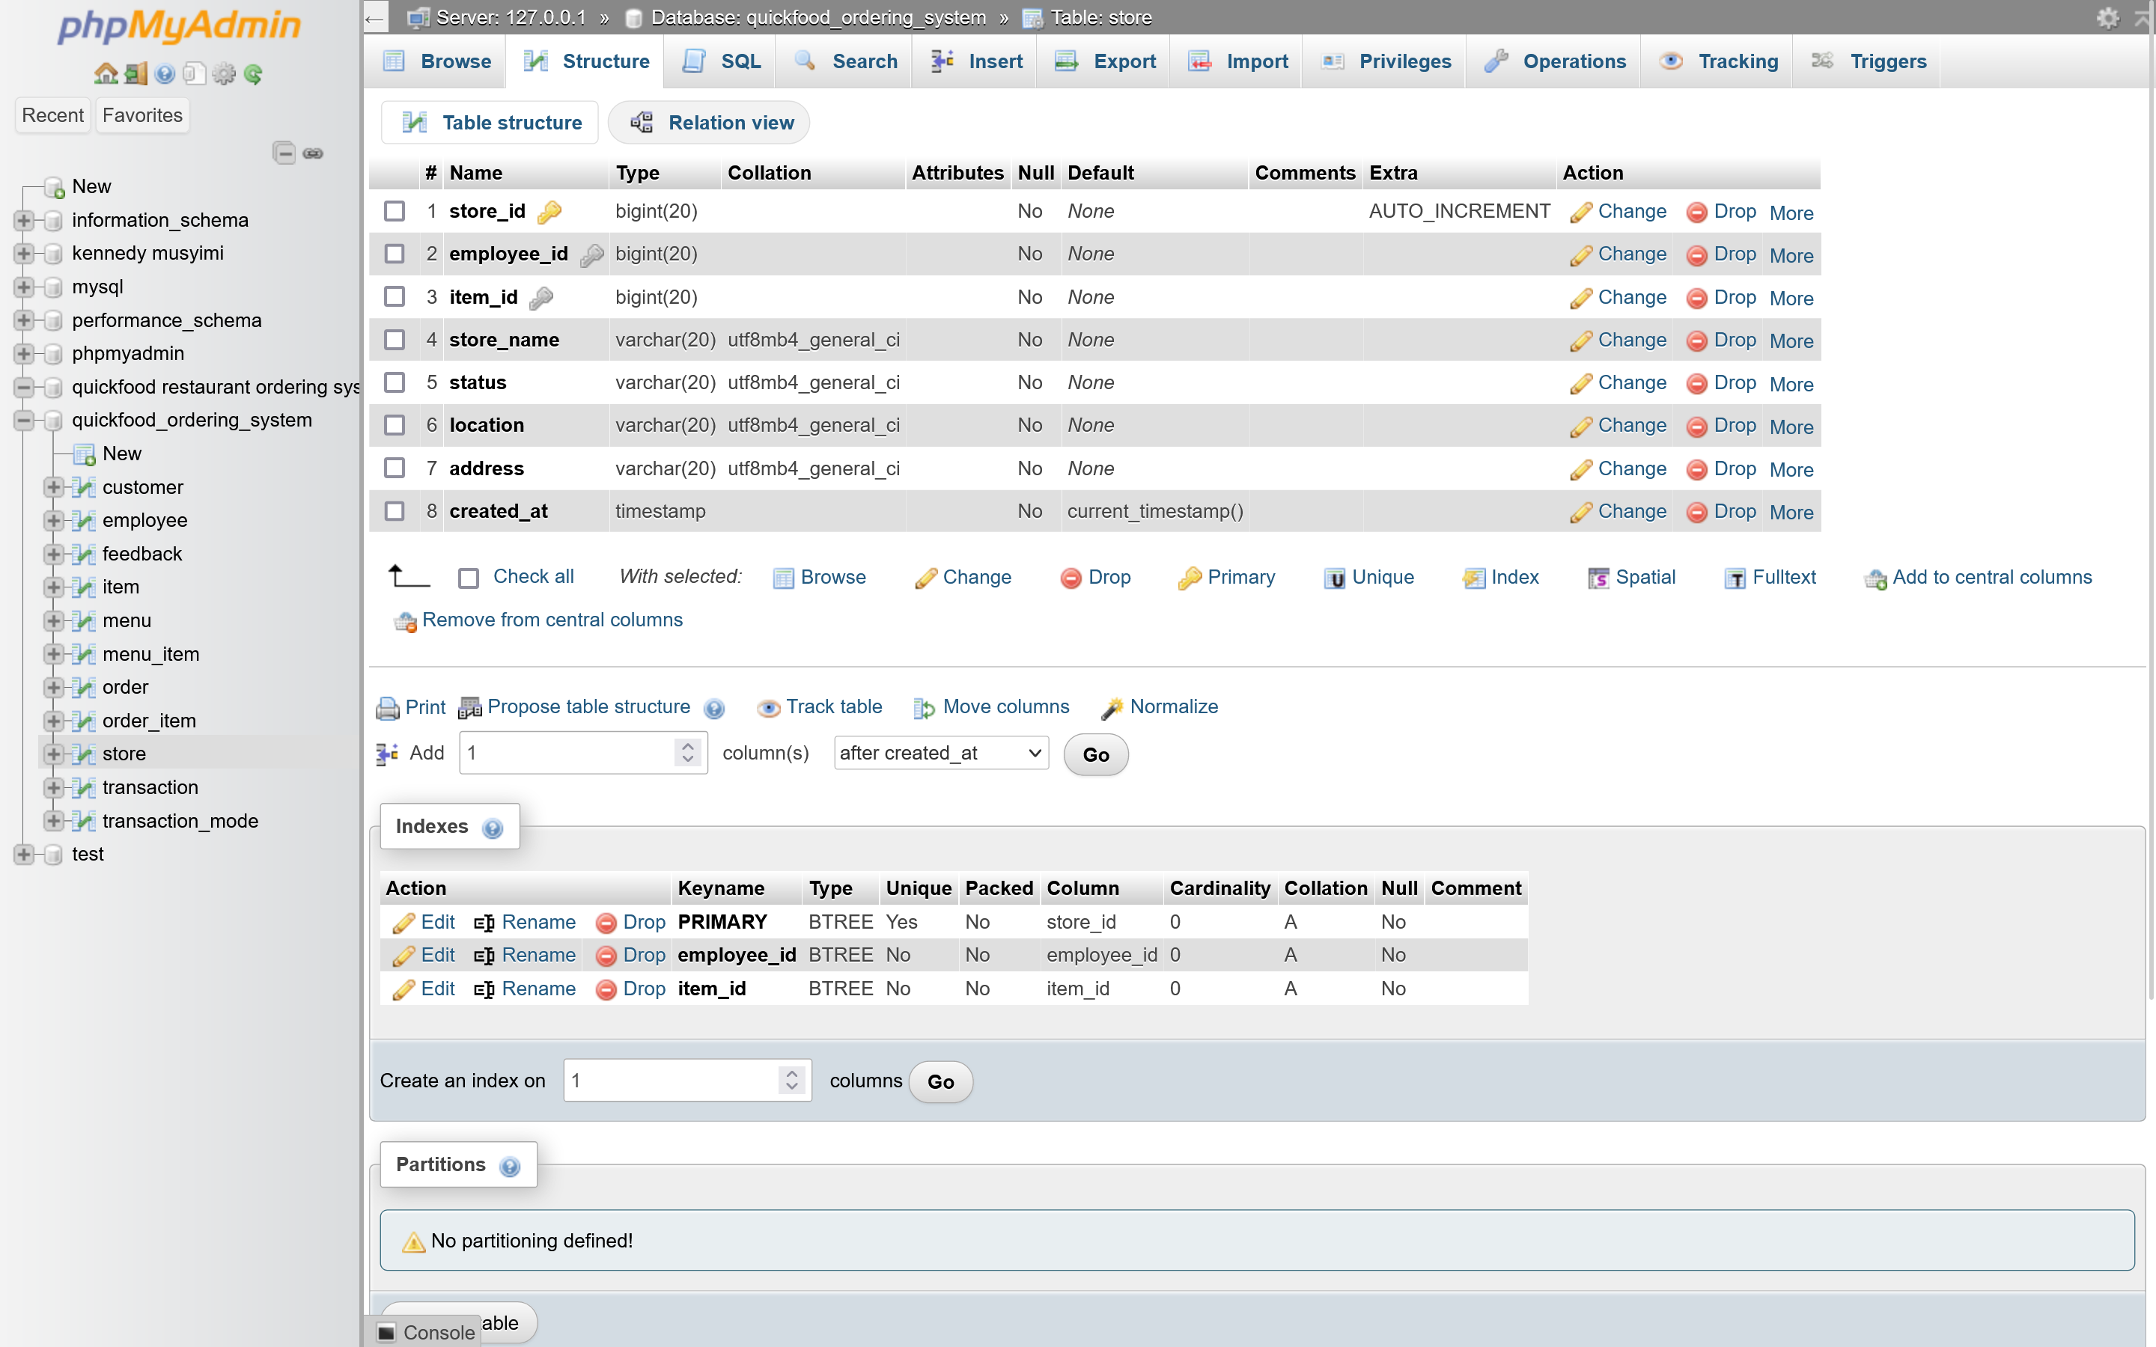

**10) Transaction’s table design**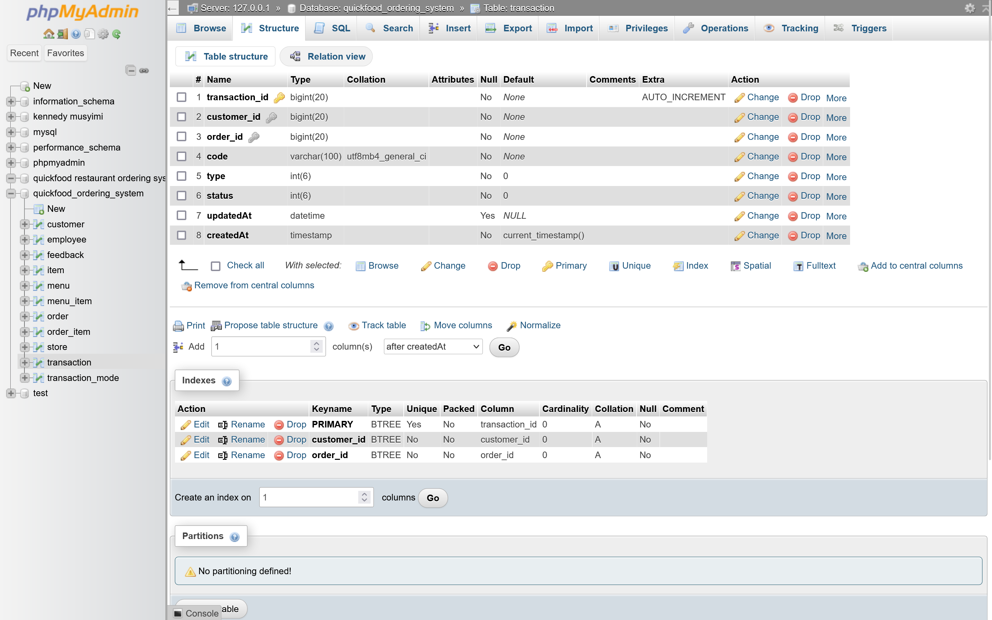

**11) Transaction mode’s table design**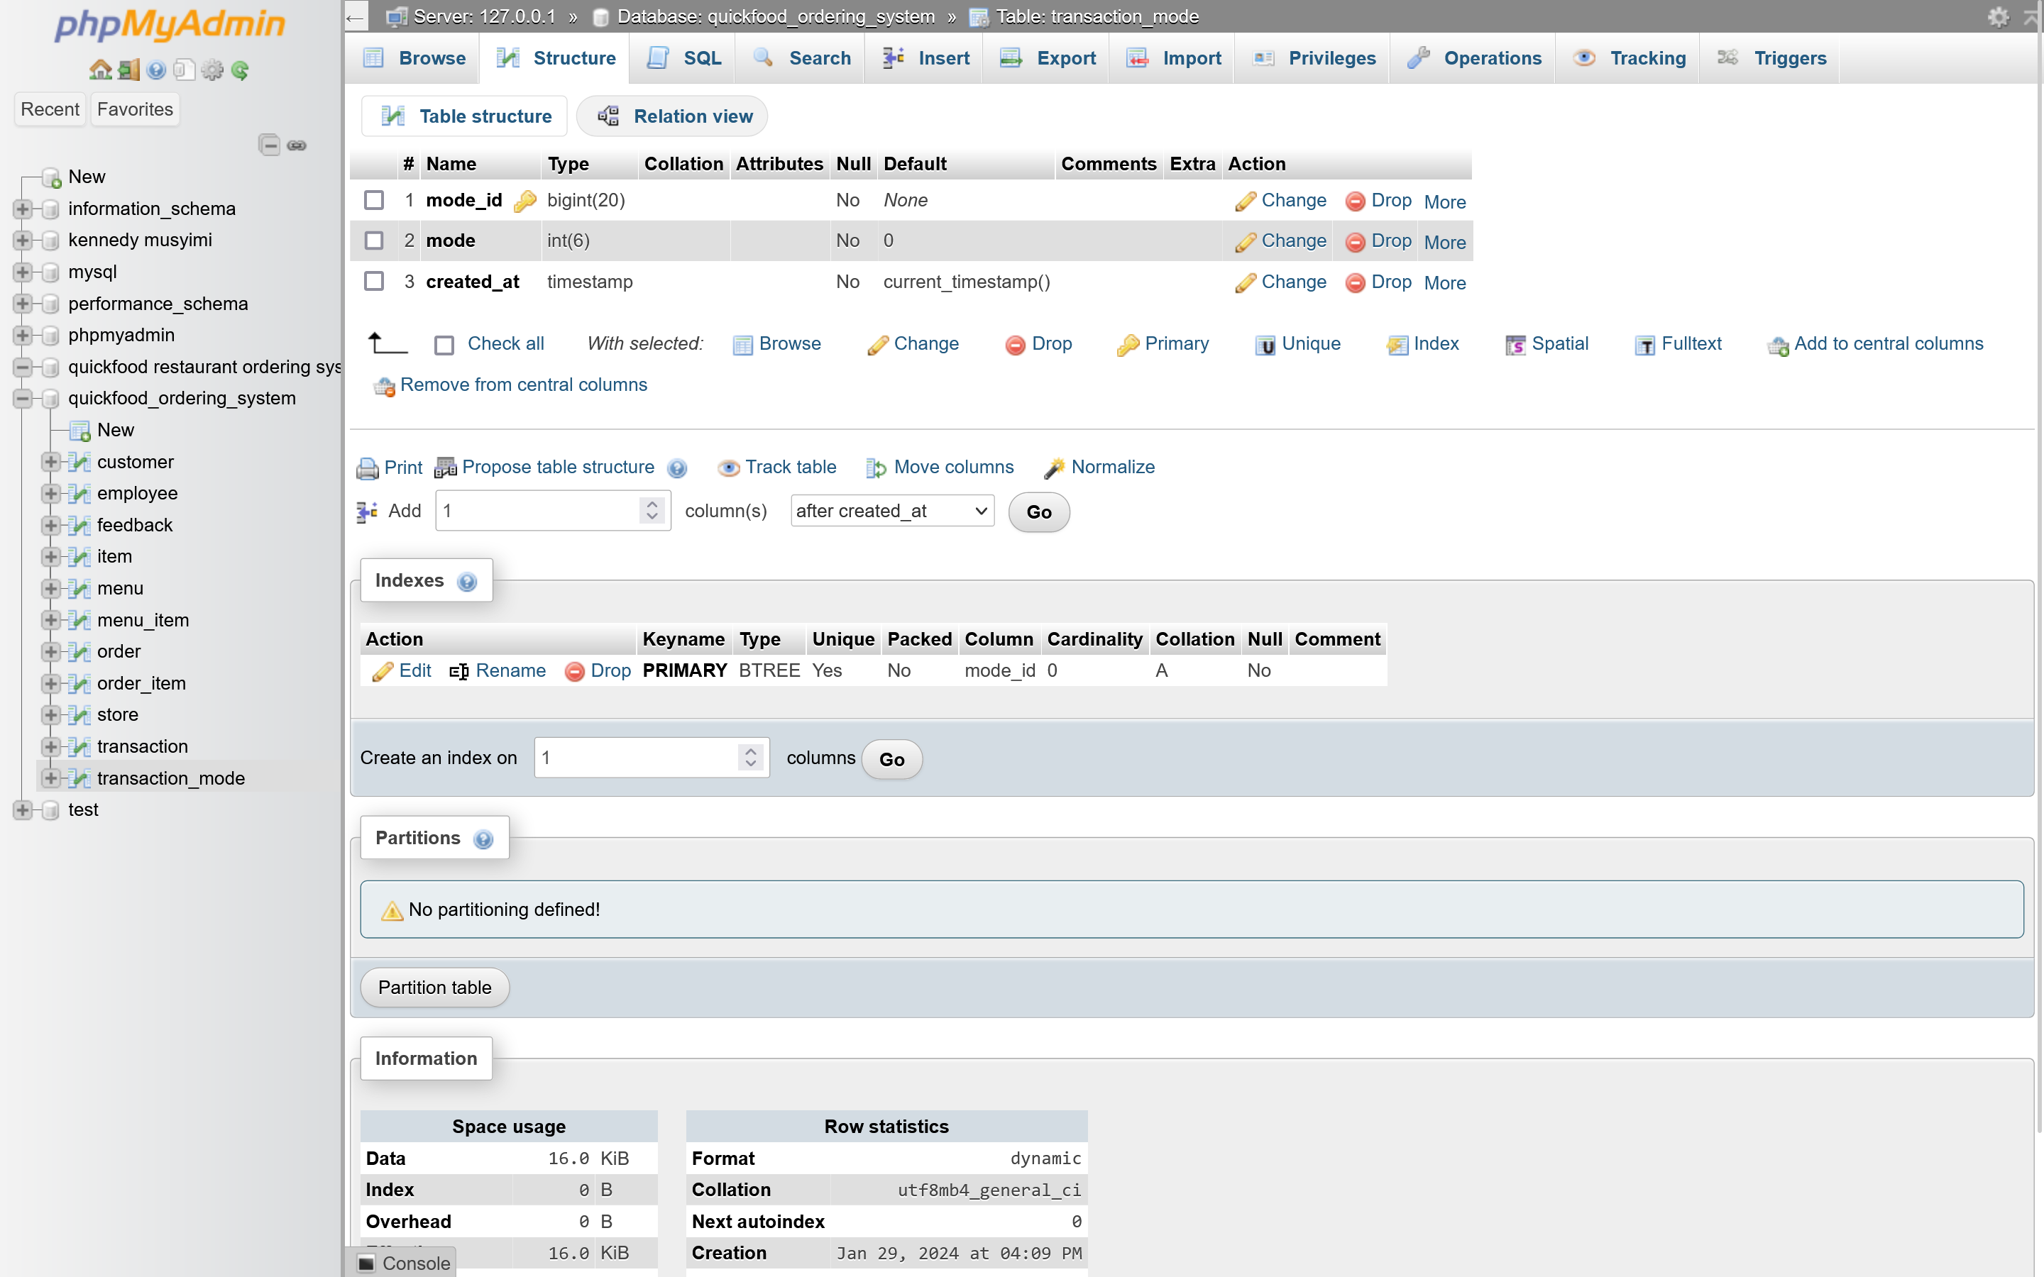

**B) QUICKFOODS RESTAURANT ORDERING SYSTEMS RELATIONSHIP BETWEEN TABLES**

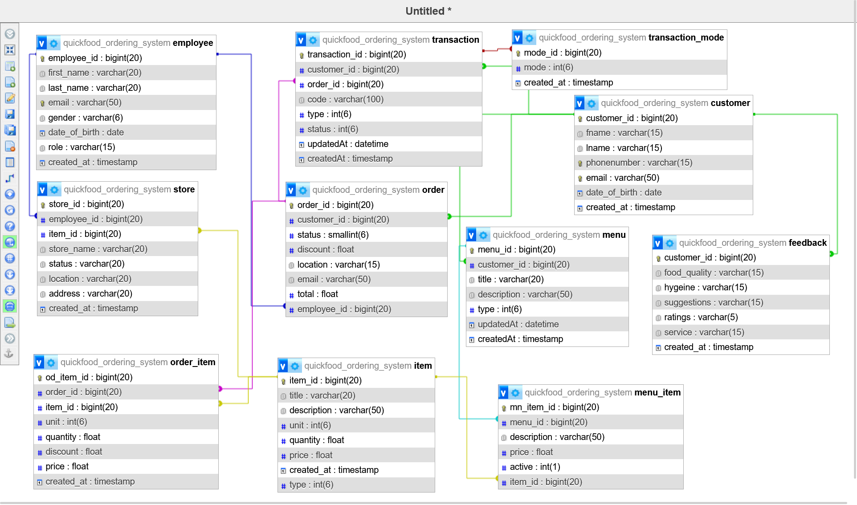

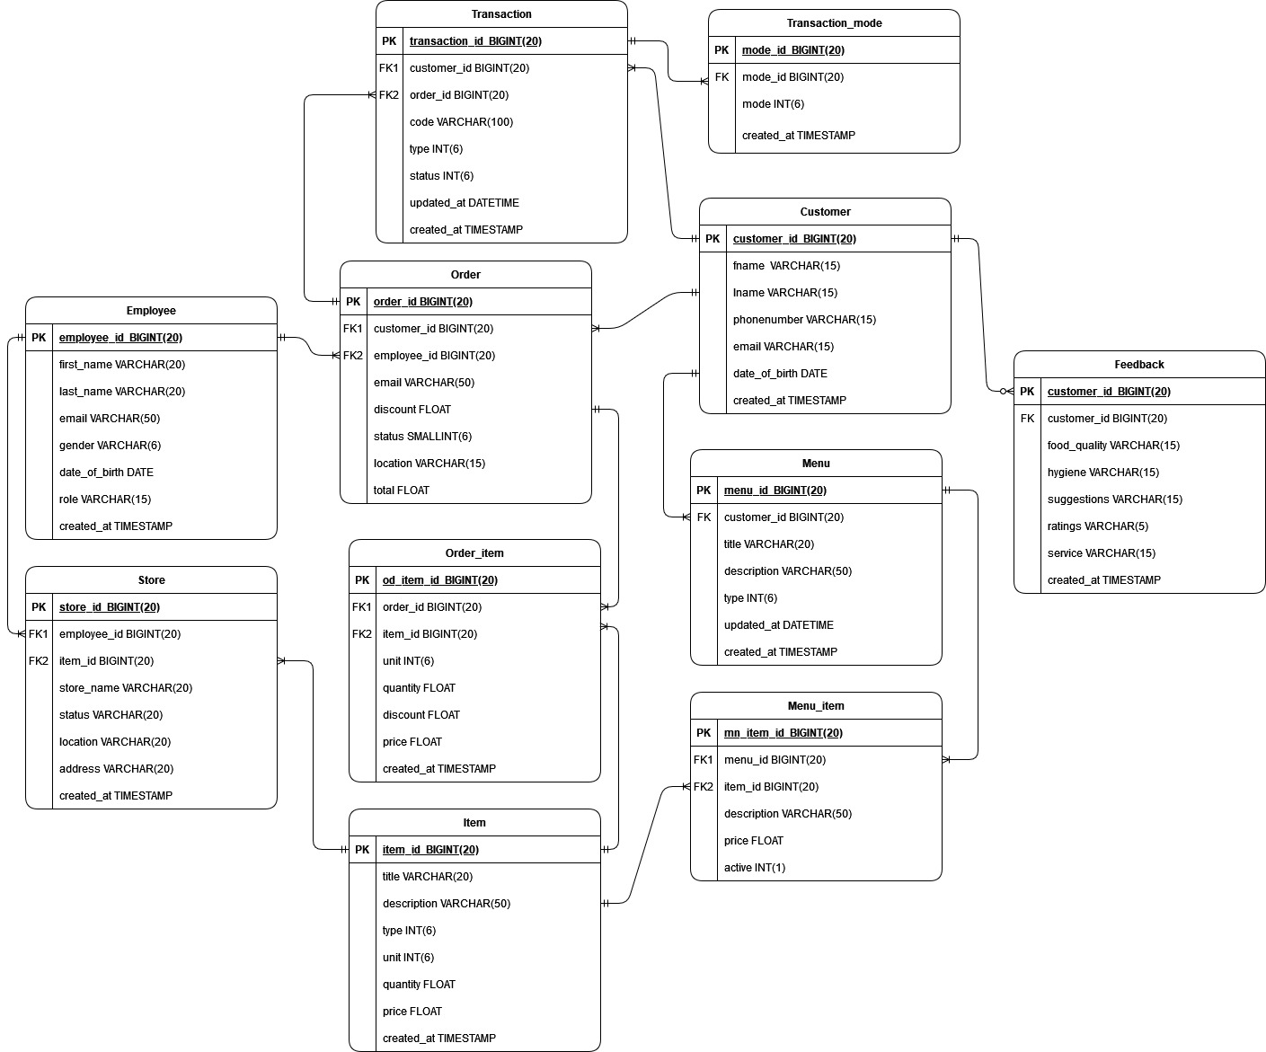

**D) QUICKFOODS RESTAURANT ORDERING SYSTEMS DATA INPUT FORMS**

**1) CUSTOMER INPUT FORM**

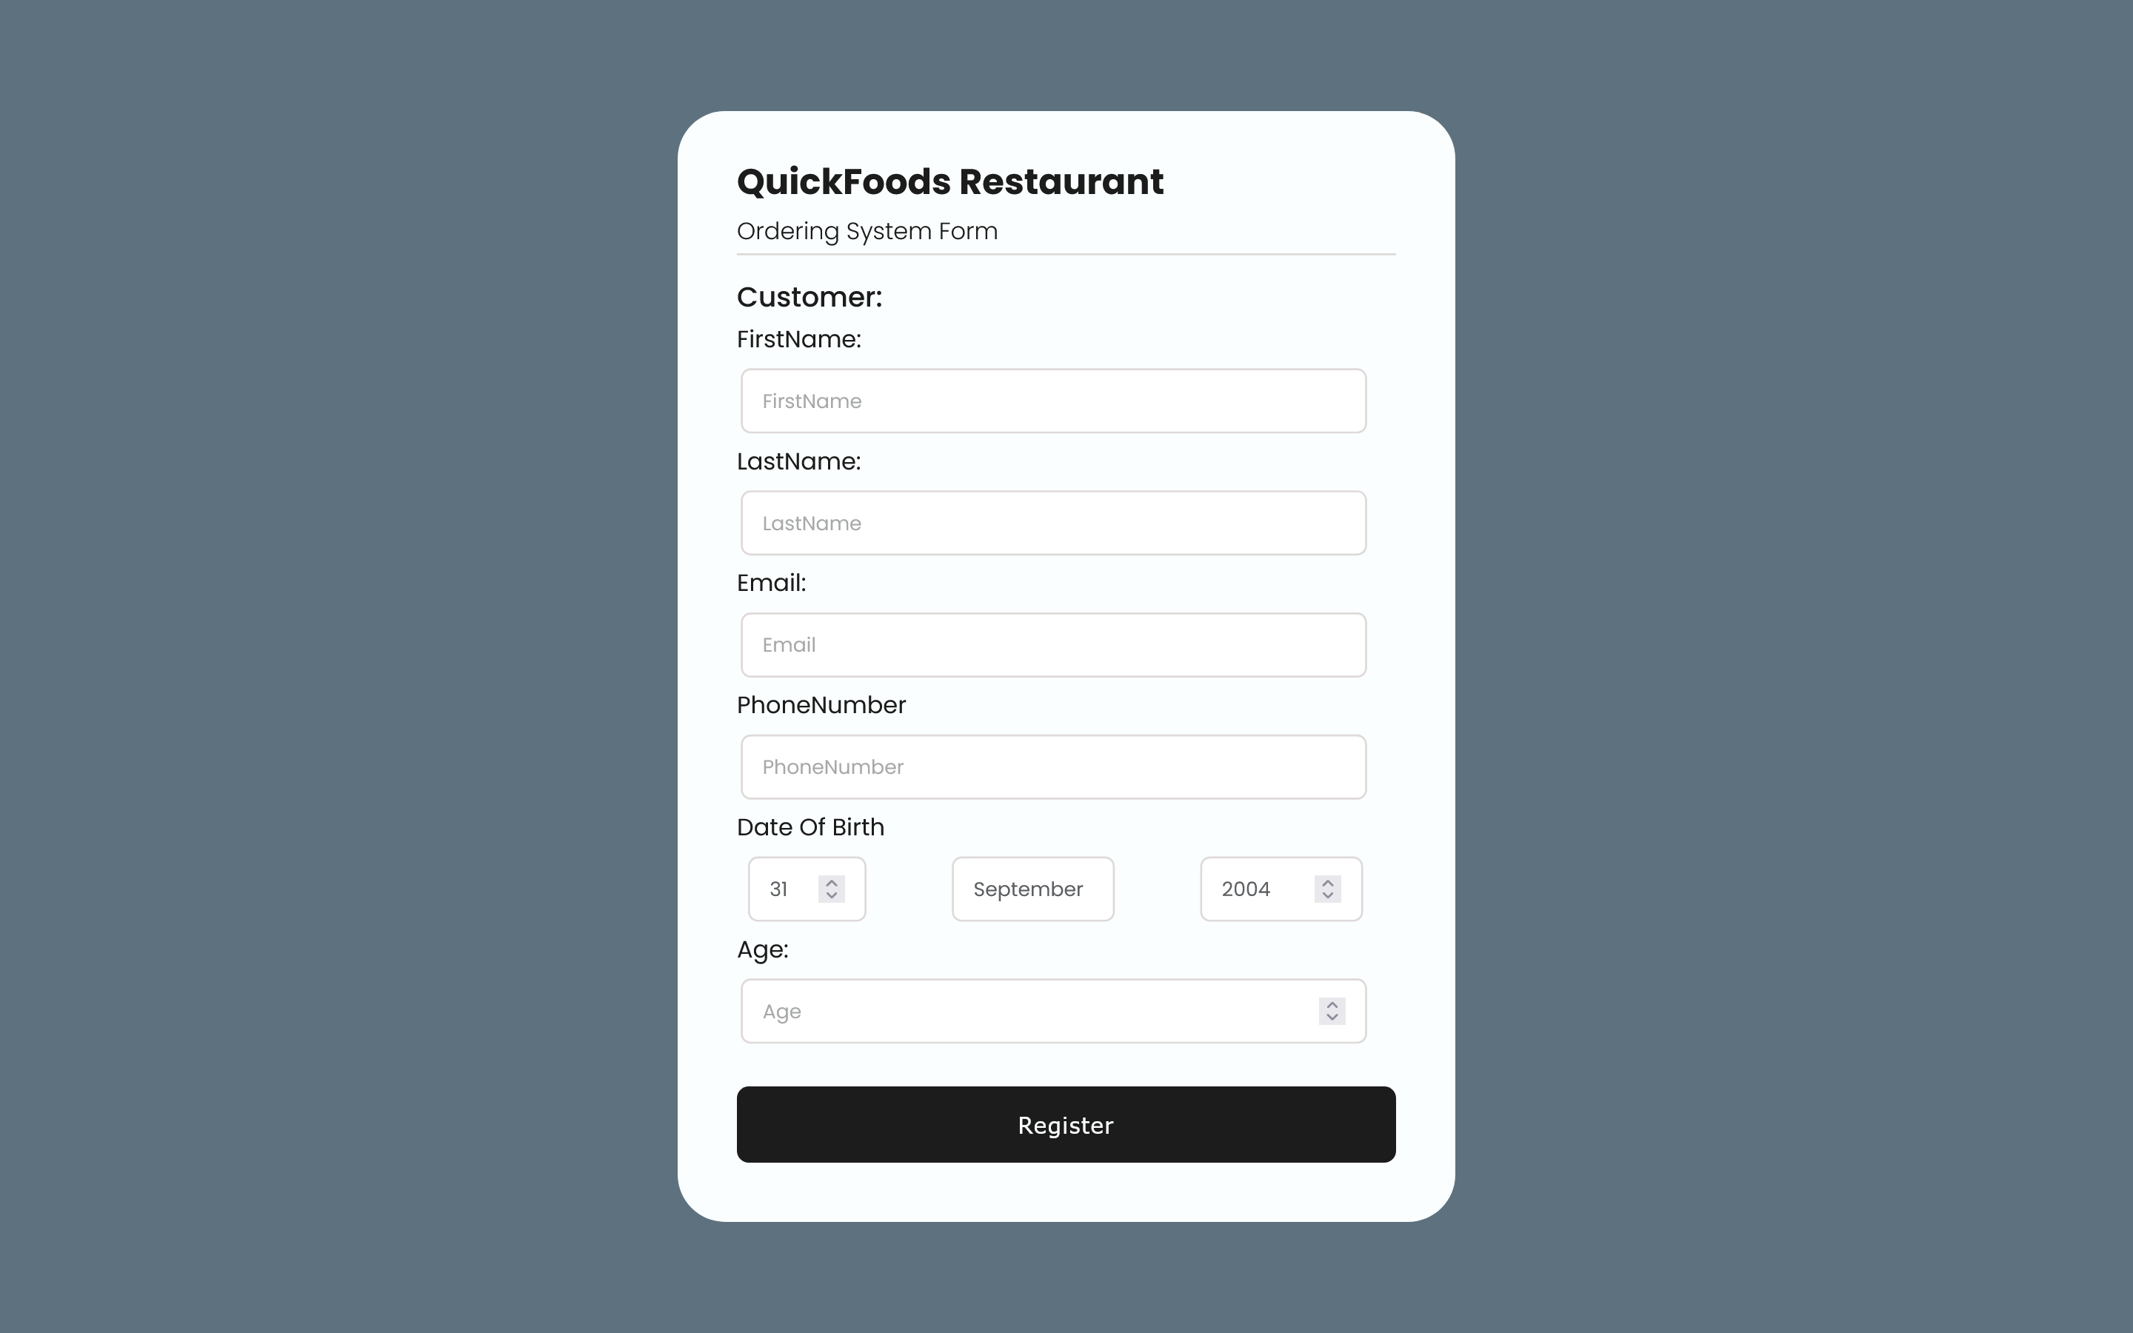

**2) ORDER INPUT FORM**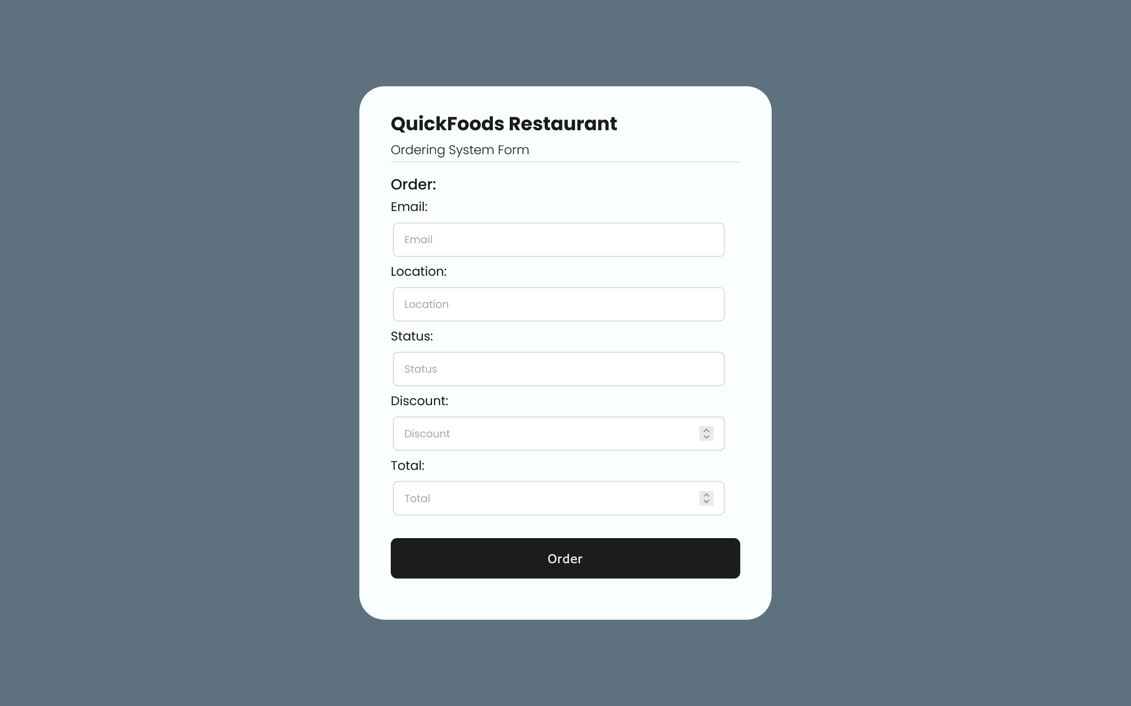

**3) ORDER ITEM INPUT FORM**

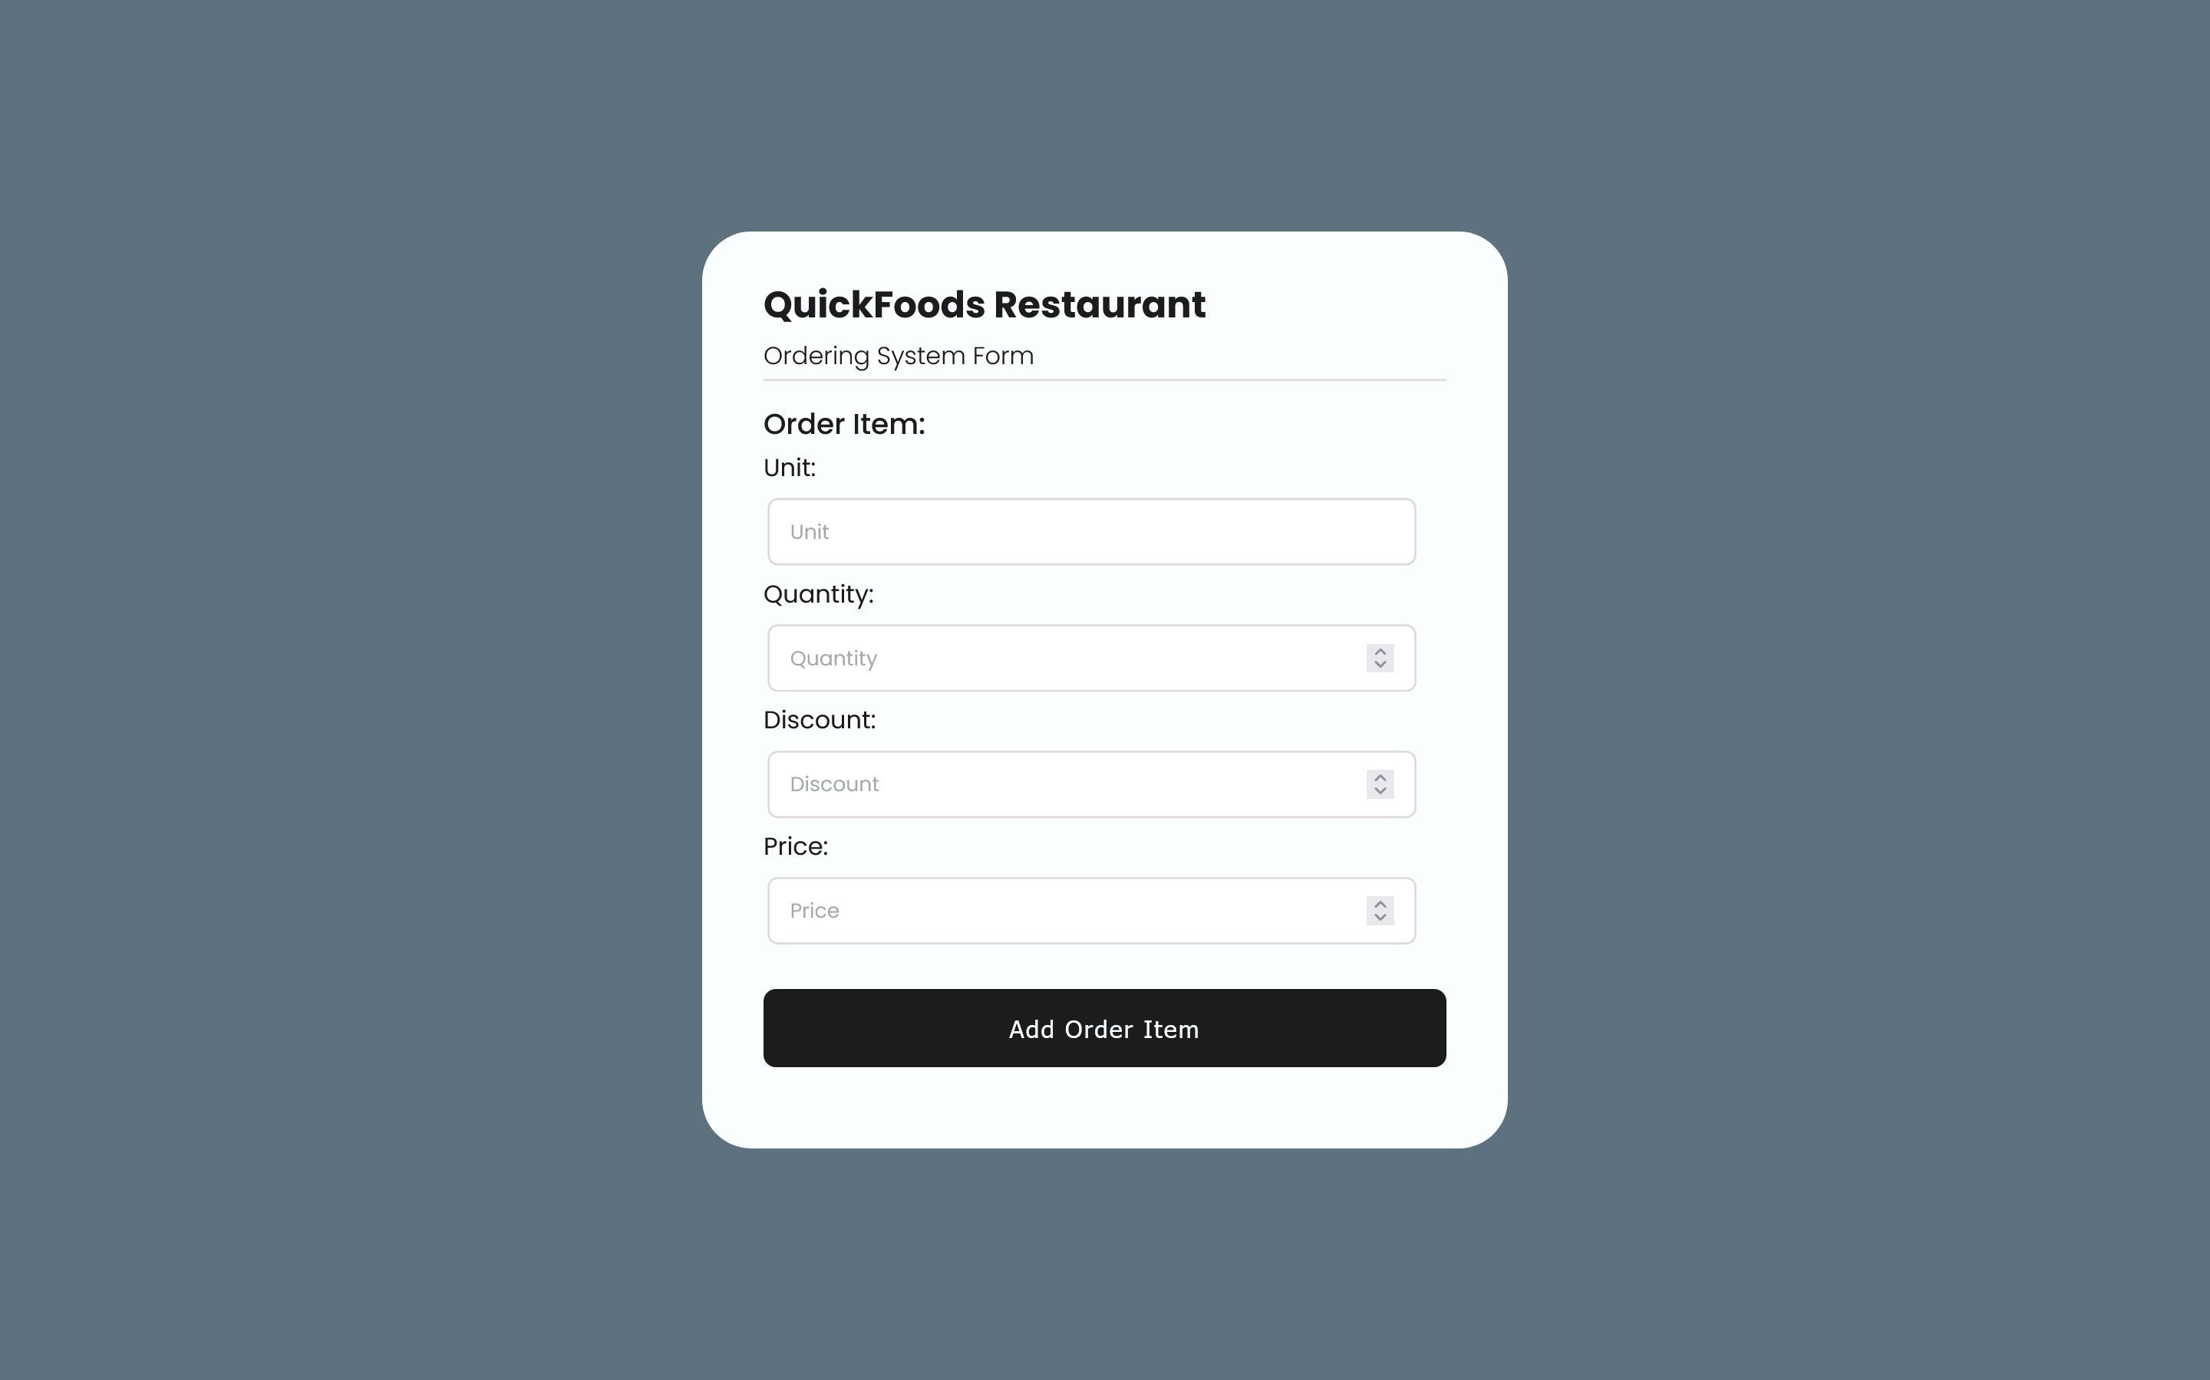

**4) TRANSACTION INPUT FORM**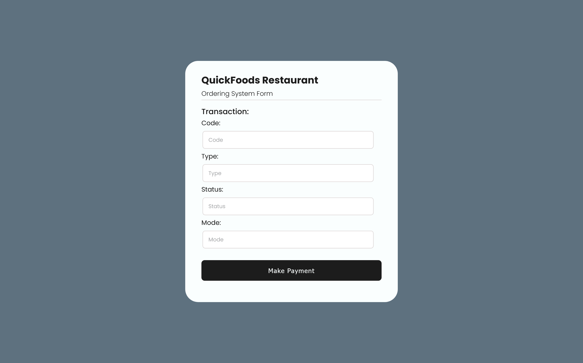

**5) FEEDBACK INPUT FORM**

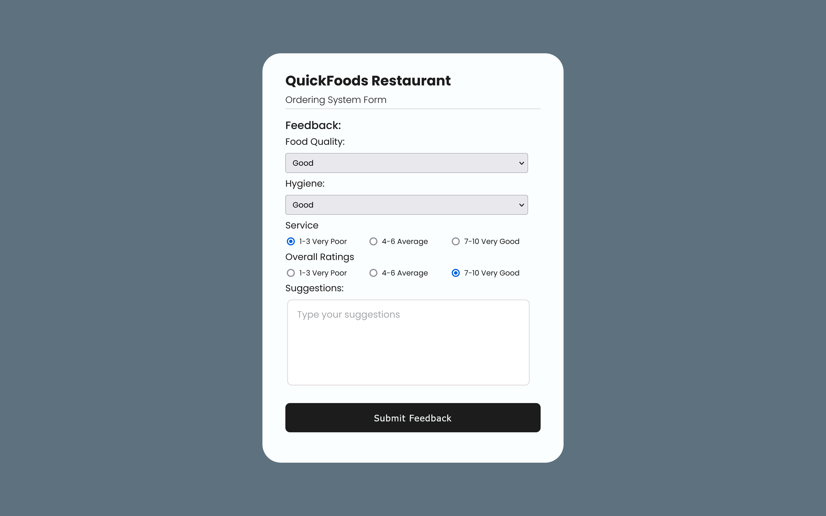

**6) MENU INPUT FORM**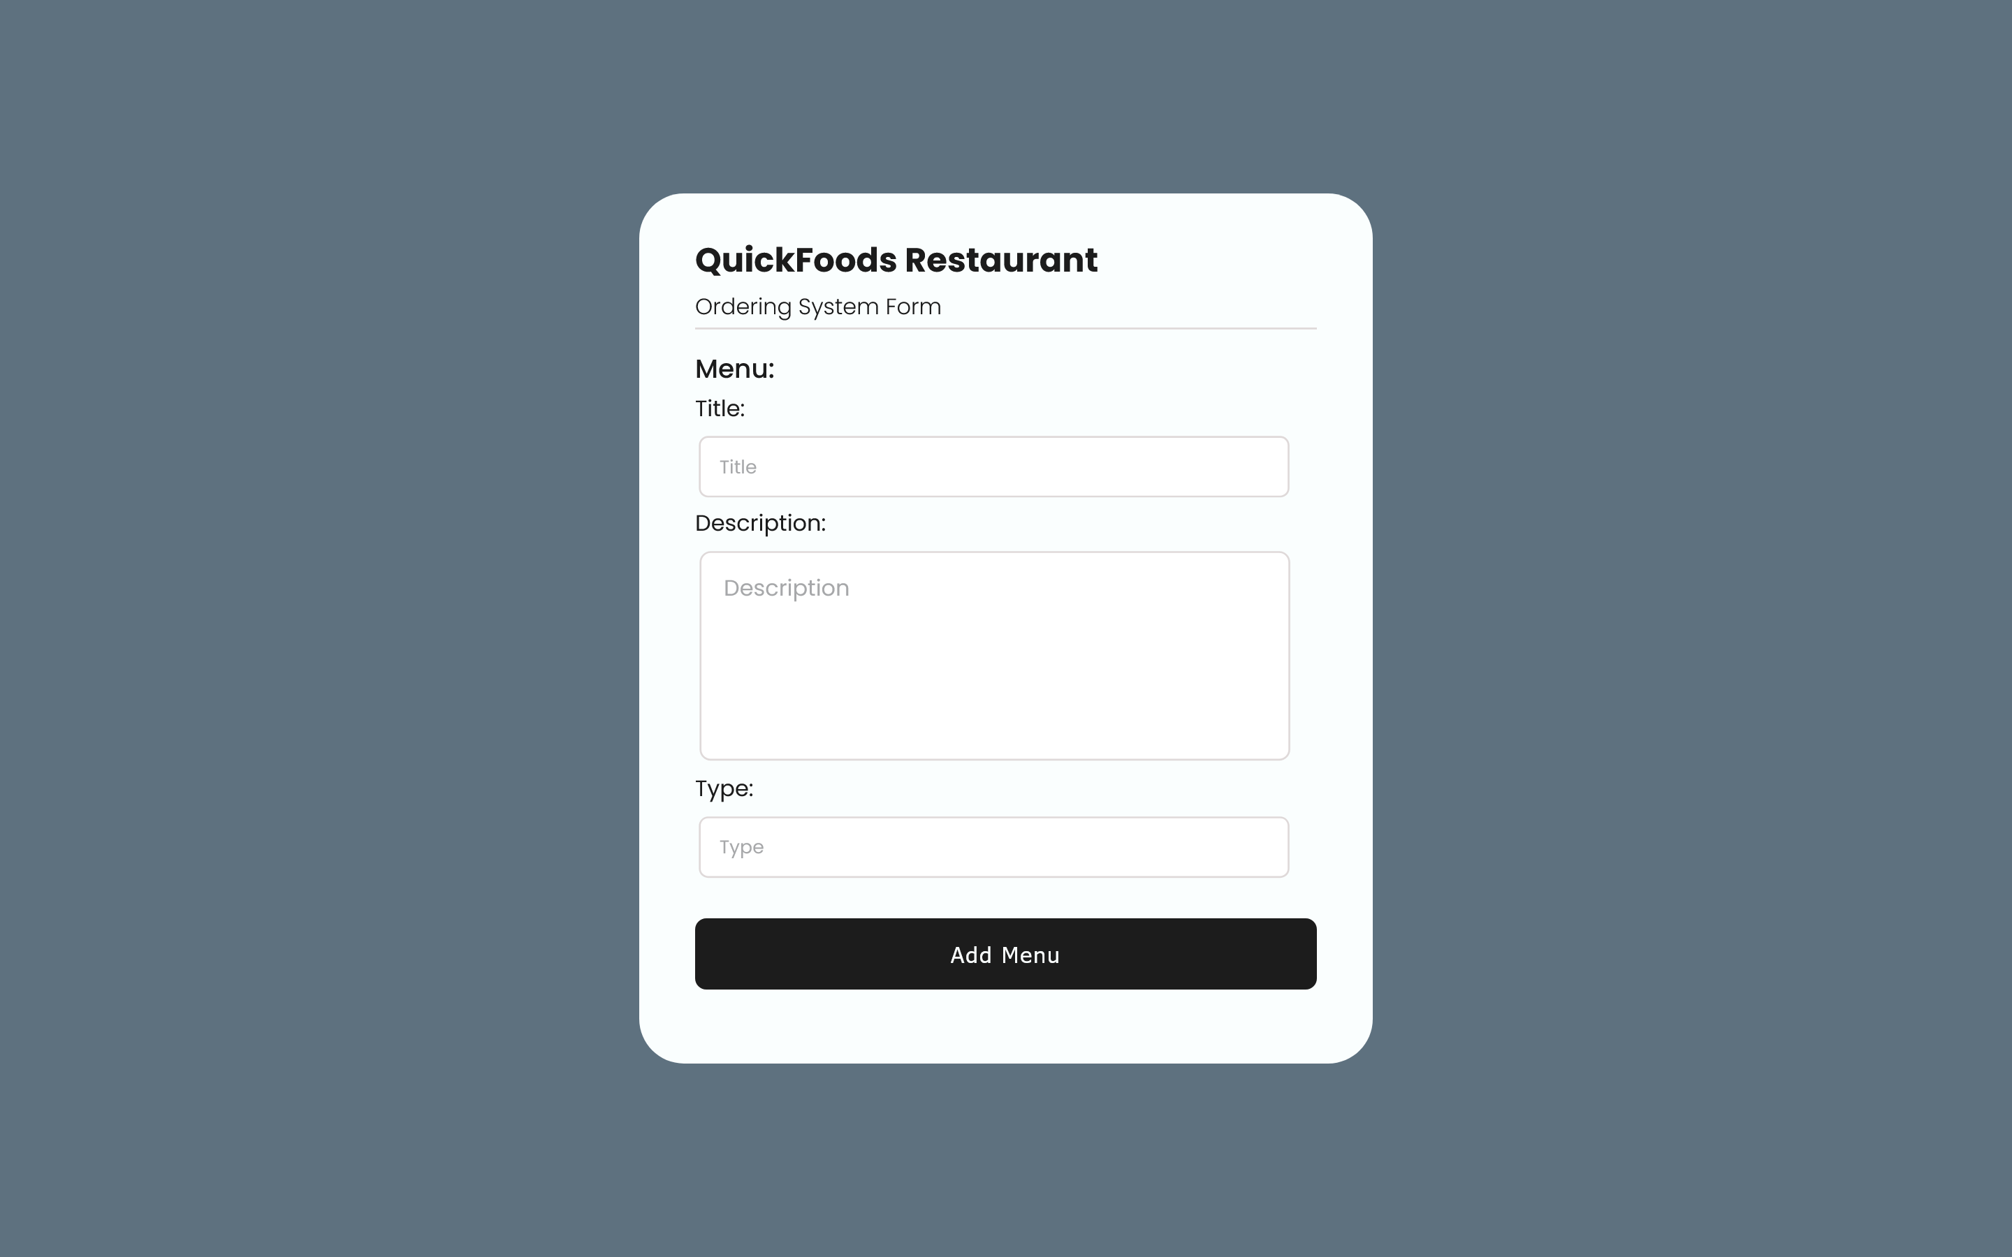

**7) MENU ITEM INPUT FORM**

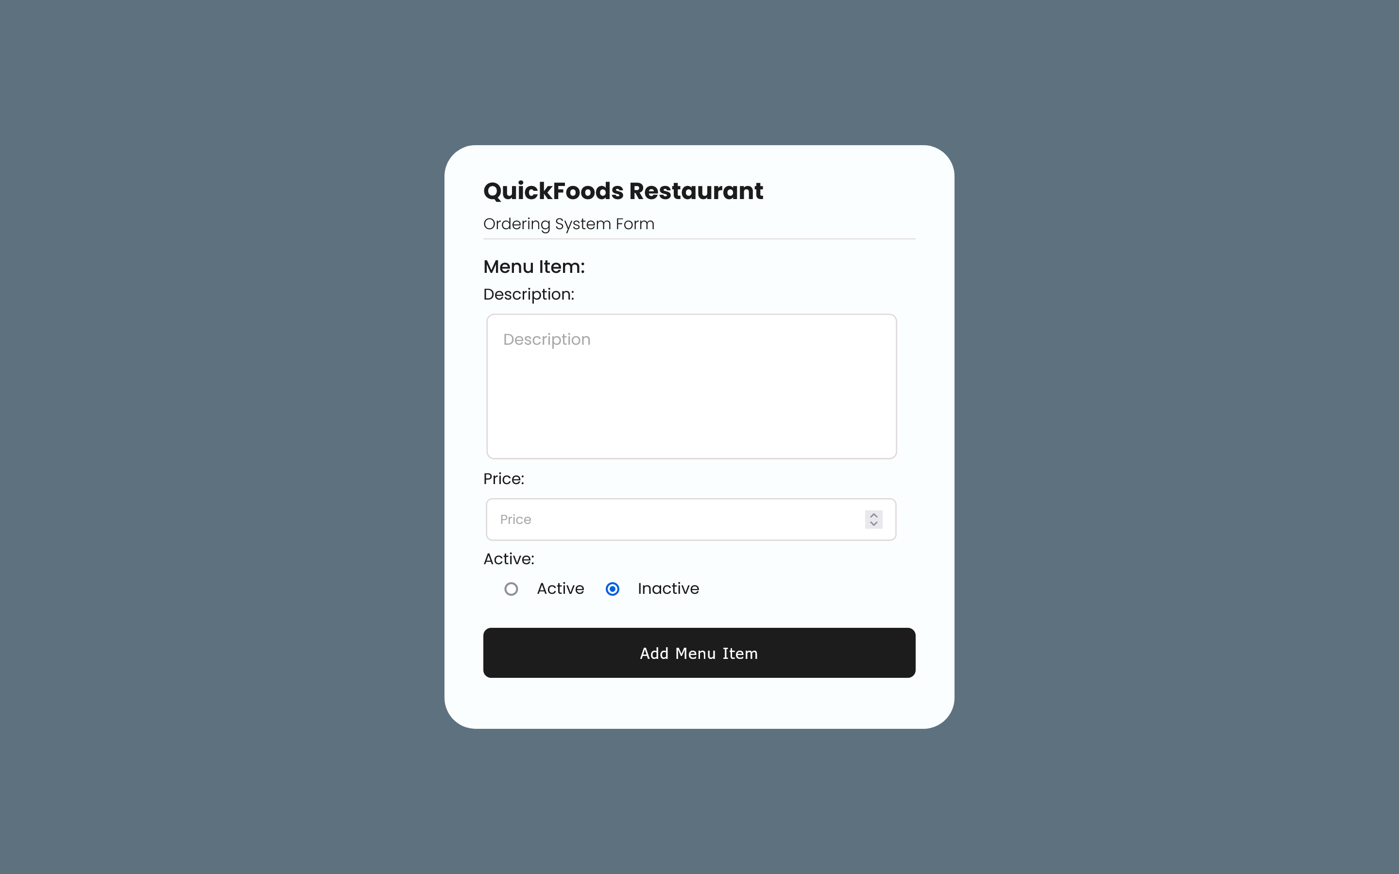

**8) ITEM INPUT FORM**

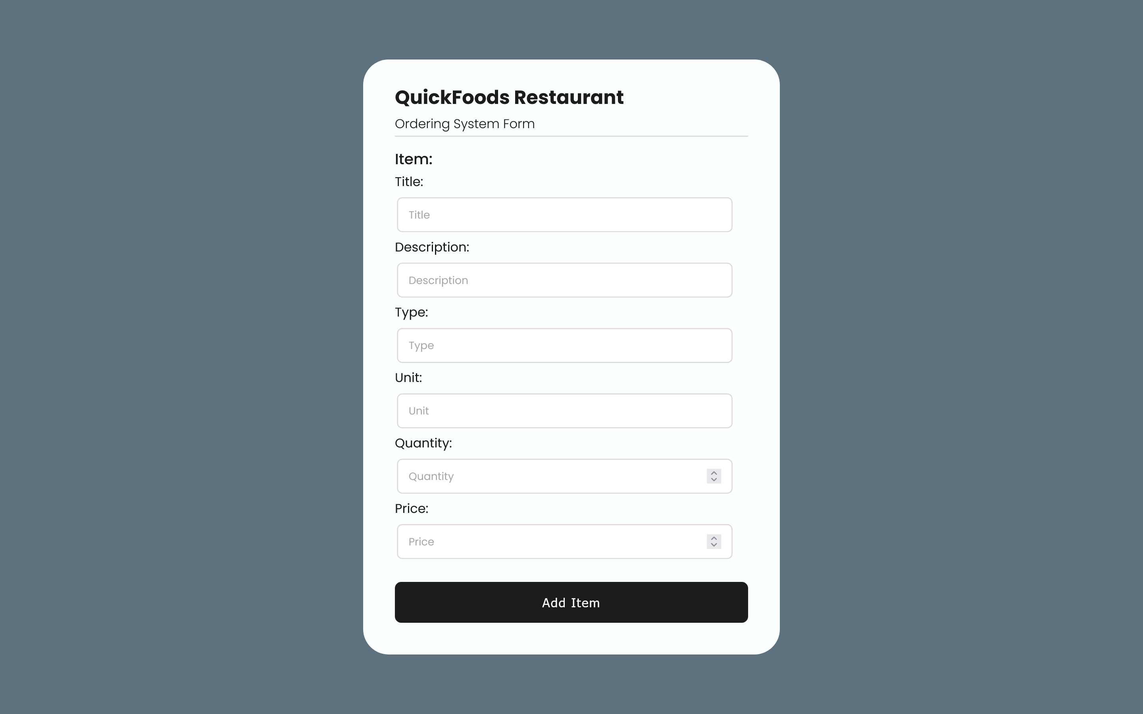

**9) STORE INPUT FORM**

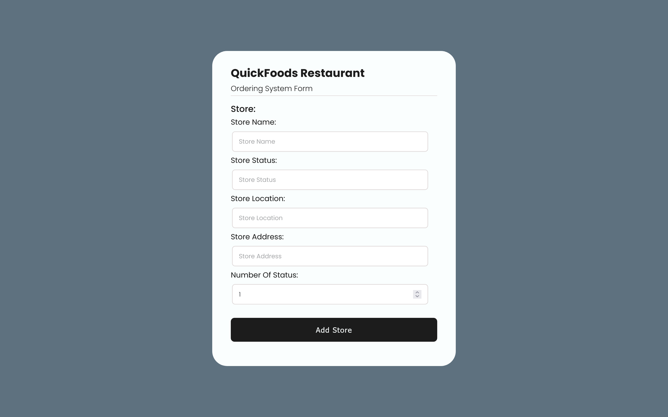

**10) EMPLOYEE INPUT FORM**

